A000-INDO-Nias-Adu Horö Uma Ancestor Figure-Wood-early 19th c.

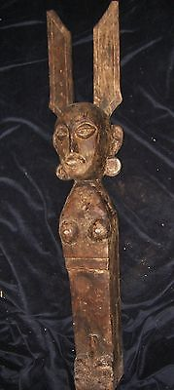

INDO-Nias- Adu Horö Uma Ancestor Figure-Wood-early 19th c.

**Case No.: Oceania**

**Accession No.**

**Formal Label:** INDO-Nias- Adu Horö Uma Ancestor Figure-Wood-early 19th c.

**Display Description:**

**LC Classification:**

**Date or Time Horizon:** early 19th c.

**Geographical Area:**

**Map:**

**GPS coordinates:**

**Cultural Affiliation:**

**Media:**

**Dimensions:**

**Weight:**

**Condition:**

**Provenance:**

**Discussion:**

**References:**